|  |  |  |  |  |  |
| --- | --- | --- | --- | --- | --- |
| Date | 12-Dec-22 | | | Tester Name | Mayuri Patel |
| Environment | Penfax - Test | | | Login used |  |
| Operating System | Select OS | Version: | Update: | | |
| Software Used | Select Software | Version: | Update: | | |
| Select Software | Version: | Update: | | |
| Release version | 22.4.1 | | | | |
| Title |  | | | | |
| Test Type | Regression | | | | |
| Test Scenario | Process PEPP Daily Letters Report | | | | |
|  |  | | | | |
| Expected Results |  | | | | |
| Pass/Fail | Pass | | | JIRA# | N/A |

Describe your steps with screenshots:

Go to Batch process schedules

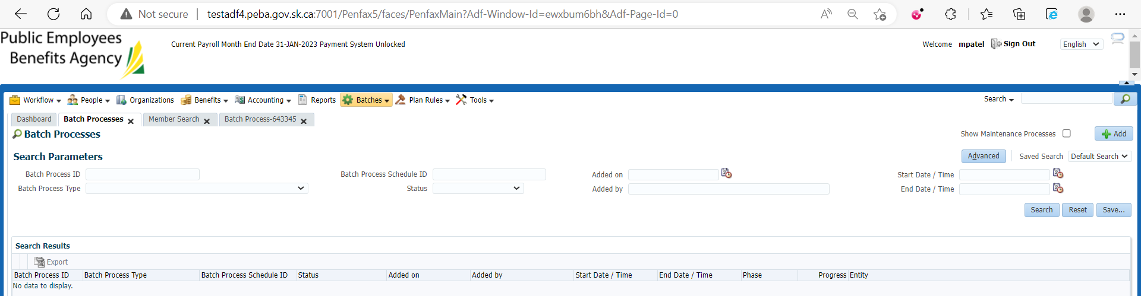

Search for PEPP Daily Letters Reports

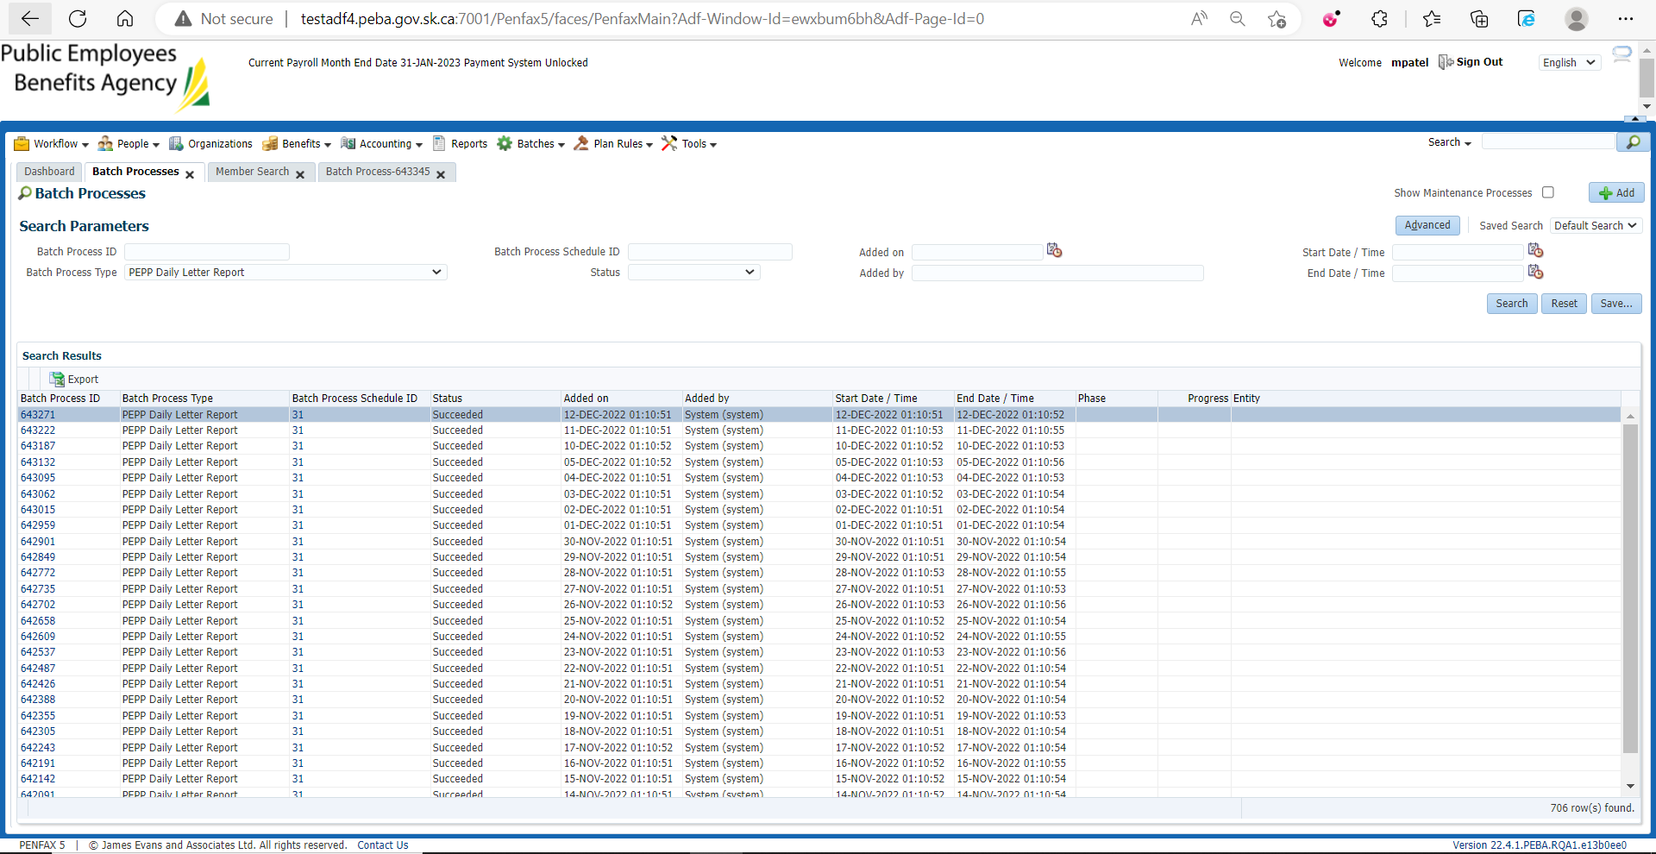

Select that Batch process

Find stakeholder ID to look for the daily Letters that are generated on that date

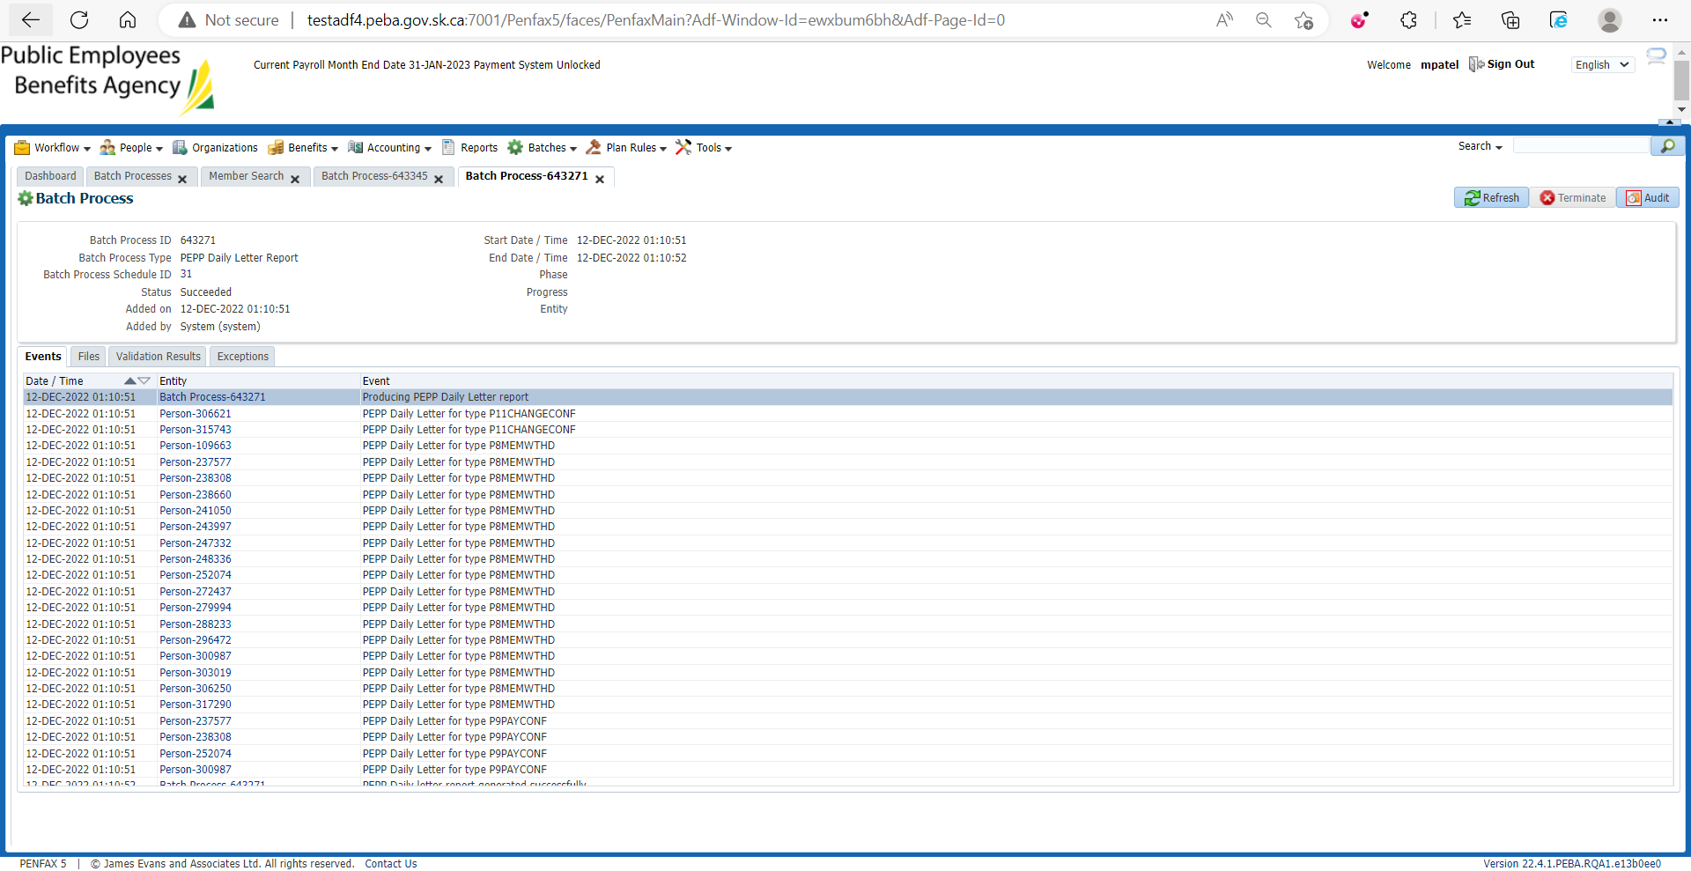

Open any member and make sure about the mentioned letter generated under Person Profile🡪 Communication

